Project Report on

**EXTRACTIVE TEXT SUMMARIZATION**

at

## U. V. Patel College of Engineering



|  |  |
| --- | --- |
| **Internal Guide:** | **Prepared By:** |
| Prof. Pravesh Patel | Mr. Nishith Patel (19012011050) |
| Asso. Professor, CE | Mr. Priyansh Patel (19012011051) |

**B. Tech Semester VII**

**(Computer Engineering)**

###### Nov-Dec 2022

Submitted to,

Department of Computer Engineering

U.V. Patel College of Engineering

Ganpat University, Kherva - 384 012

##### **U.V. PATEL COLLEGE**

##### **OF**

##### **ENGINEERING**

### 

**24/11/2022**

### CERTIFICATE

**TO WHOM SO EVER IT MAY CONCERN**

This is to certify that Mr. Nishith J. Patel (19012011050) student of **B.Tech. Semester VII (Computer Engineering)** has completed his full semester on site project work titled “**Extractive Text Summarization**” is satisfactory. Department of Computer Engineering, Ganpat University, Kherva, Mehsana in the year 2022.

|  |  |
| --- | --- |
| **Prof. Pravesh Patel** | **Dr. Paresh M. Solanki** |
| **Project Guide** | **Head, Computer Engineering** |

##### **U.V. PATEL COLLEGE**

##### **OF**

##### **ENGINEERING**

### 

**24/11/2022**

### CERTIFICATE

**TO WHOM SO EVER IT MAY CONCERN**

This is to certify that Mr. Priyansh S. Patel (19012011051) student of **B.Tech. Semester VII (Computer Engineering)** has completed his full semester on site project work titled “**Extractive Text Summarization**” is satisfactory. Department of Computer Engineering, Ganpat University, Kherva, Mehsana in the year 2022.

|  |  |
| --- | --- |
| **Prof. Pravesh Patel** | **Dr. Paresh M. Solanki** |
| **Project Guide** | **Head, Computer Engineering** |

**ACKNOWLEDGEMENT**

This satisfaction that successful completion of any task would be incomplete without the mention of people whose ceaseless cooperation it made it possible, whose constant guidance and encouragement crown all efforts with success. We are grateful to our guide **Prof. Pravesh Patel** for the guidance, inspiration and constructive suggestions that helpful us in the preparation of this project. We also thank our colleagues who have helped in successful completion of the project.

**NISHITH PATEL [19012011050]**

**PRIYANSH PATEL [19012011051]**

**INDEX**

|  |  |  |
| --- | --- | --- |
| **CHAPTER NO.** | **CHAPTER NAME** | **PAGE NO.** |
|  | Abstract | I |
|  | List of Figures | II |
| 1 | **INTRODUCTION** | 1 |
| 2 | **PROJECT SCOPE**  2.1 Purpose  2.2 Project Scope  2.3 Problem Statement  2.4 Overview  2.5 Objective  2.6 Tools & Technology | 2 |
| 3 | **FEASIBILITY STUDY**  3.1 Study of Current System  3.2 Problem and weakness in current system  3.3Requirement of new system  3.4 Technical Feasibility  3.5 Technical Feasibility  3.6 Operational Feasibility  3.7 Requirement Validation  3.8 Features of New System  3.9 Literature Survey | 6 |
| 4 | **SOFTWARE AND HARDWARE REQUIREMENTS** | 8 |
| 5 | **PROJECT PLANNING** | 9 |
| 6 | **SYSTEM REQUIREMENT STUDY**  6.1 Functional Requirement  6.2 Non-Functional Requirement | 10 |
| 7 | **SYSTEM DESIGN** |  |
| 8 | **CONCLUSION** | 11 |
| 9 | **REFERENCE** |  |

**ABSTRACT**

Since the amount of information on the internet is growing rapidly, it is not easy for a user to find relevant information for his/her query. To tackle this issue, much attention has been paid to Automatic Document Summarization. The key point in any successful document summarizer is a good document representation.

Automatic text summarization is a major area of research in the domain of information systems. Most of the methods requires domain knowledge to produce a coherent and meaningful summary. In Extractive text summarization, sentences are scored on some features. Many feature-based scoring methods have been proposed for extractive automatic text summarization by researchers.

Text summarization is the process of automatically creating a shorter version of one or more text docu-

ments. It is an important way of finding relevant information in large text libraries or in the Internet.

Essentially, text summarization techniques are classified as Extractive and Abstractive. Extractive tech-

niques perform text summarization by selecting sentences of documents according to some criteria.

Abstractive summaries attempt to improve the coherence among sentences by eliminating redundancies

and clarifying the contest of sentences. In terms of extractive summarization, sentence scoring is the

technique most used for extractive text summarization.

**LIST OF FIGURES**

|  |  |  |
| --- | --- | --- |
| **FIGURE NO.** | **FIGURE NAME** | **PAGE NO.** |
| 1 | Process Flowchart | 4 |
| 2 | Broad Classification of Text Summarization | 5 |

# **INTRODUCTION**

Text summarization is a method used to generate summaries of text documents by extracting important information from the summarized document. It is used extensively in summarizing the search engine results, providing brief version of large documents in which abstracts are not present. A summary of a text document is useful for humans to quickly extract the important information in the text.

The rapid growth of the Internet yielded a massive increase of the amount of information available, especially regarding text documents (e.g. news articles, electronic books, scientific papers, blogs, etc.).Text summarization involves two types, abstractive and extractive. In ABSTRACTIVE it considers human knowledge and understands the text in order to generate the summary whereas in EXTRACTIVE the important sentence is picked from the text as a summary. However multiple documents can also be summarized by choosing the proper integration algorithms.

The text summarization using sentence scoring involves four phases: - Pre-Processing, Sentence Scoring, Sentence Ranking, Summary Extraction. The text document is selected and data in it is segmented into sentences and tokens during the pre-processing stage. Each sentence is evaluated in sentence scoring by considering the linear combination of multiple parameters like frequency, sentence position, cue words, similarity with title, sentence length and proper noun. The sentences are ranked with respect to the scores. The summary is generated by selecting the required number of sentences with highest rank and it is made sure that notwo consecutive sentences are selected.

The Text Summarization is very helpful in daily tasks. Some of the day to day real life applications of text summarization are Media monitoring, Newsletters, Search marketing and SE, Financial research, Social media marketing, Question answering and bots, Books and literature, Email overload, Science and R&D, Automated content creation.

**1.2 Classification of Text Summarization**

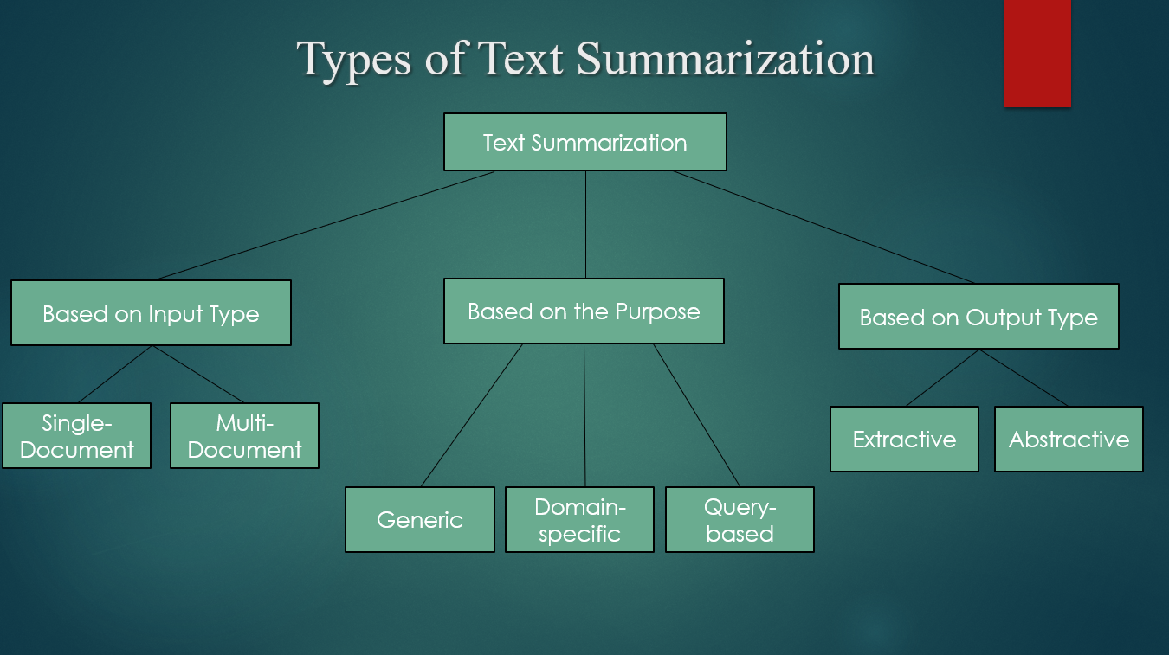

*Figure 1*

* **Single Document Summarization**

This is basically self-explanatory. Single document summarizers aim to summarize one single document. Given a single document to generate a summary.

* **Multiple Document Summarization**

Given a group of documents to generate a summary out of it. Multiple Document or multiple text summarization includes multiple documents and the final paper has to contain summarized information from all the documents.

* **Generic Summarization**

Summarize the content of a document. Generic summarizations are not programmed to make any assumptions like the domain-specific or query-based summarizers. It just condenses or summarizes the information from the source document.

* **Domain Specific**

Text summarization aims at extracting the essential information from a text to produce a shorter version, such as generating headlines for news and subject lines for emails. Domain knowledge is used in domain-specific summarization. Domain-specific summarizers can be integrated with specific context, knowledge, and words. For example, models can be integrated with words used in medical science so that it can better understand scientific articles on medical science and summarize them.

* **Query-focused Summarization**

Summarize a document with respect to an information need expressed in a user query. Query-based summaries mostly contain information about natural language questions. This is similar to Google’s search results. Sometimes we type in questions on the search bar and Google shows us websites or articles that have answers to our questions. It shows us a snippet or summary of an article related to the question we searched.

* **Extractive Text Summarization**

Extraction-based summarization is a simple process. The important words and phrases are taken out of the original text and compiled together to make the summary. There is no rephrasing or using synonyms in this summarization process. The words are taken out as they are and slightly rearranged to give the sentence a structure. Because there is no use of synonyms and no rephrasing, it makes the summarization process easier. Create the summary from phrases or sentences in the given documents

* **Abstractive Text Summarization**

Abstraction-based summarization is more complex than extraction-based summarization. It takes out the original and important sentence from a text document and rephrases it with proper synonyms. That way, it will look like a completely different text but have the same meaning as the original text.

That is why it is difficult because figuring out the right synonyms and rephrasing by keeping the meaning the same is tough. Express the idea in the source document using different word

**1.3 Extractive Text Summarization Flow Chart**

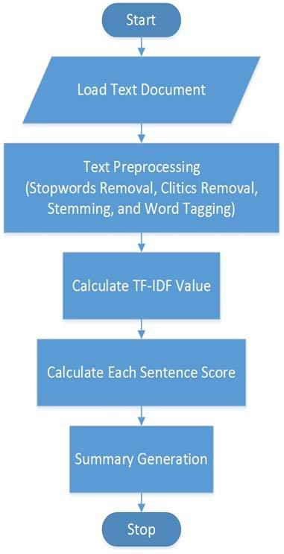

*Figure 2*

## 2. PROJECT SCOPE

## 2.1 Purpose

With the present explosion of data circulating the digital space, which is mostly non-structured textual data, there is a need to develop automatic text summarization tools that allow people to get insights from them easily. Currently, we enjoy quick access to enormous amounts of information. However, most of this information is redundant, insignificant, and may not convey the intended meaning. Therefore, using automatic text summarizers capable of extracting useful information that leaves out inessential and insignificant data is becoming vital. Implementing summarization can enhance the readability of documents, reduce the time spent in researching for information, and allow for more information to be fitted in a particular area.

## 2.2 Project Scope

The main contribution of this work is proposing an unsupervised approach for extractive single-document summarization. The rapid growth of the Internet yielded a massive increase of the amount of information available, especially regarding text documents (e.g. news articles, electronic books, scientific papers, blogs, etc.).Hence, Automatic text summarization is a process of condensing the text document automatically by computer system such that the produced summary is no longer than a specified threshold [typically one-third of the size of original text] and covers all the information contents of it which helps user to read the whole document very easily.

## 2.3 Problem Statement

Exponential growth of textual documents on web in the last few decades forced researchers to find ways so that users can save their time and resources in finding relevant information. On the other side the information contents should also be preserved. The produced text summary should be a true condensed replica of the original text. Text summarization is a method used to generate summaries of text documents by extracting important information from the summarized document.

**2.4 Overview**

The amount of information available has significantly increased because of the Internet's explosive expansion, particularly in the area of text materials. Text summarizing is a technique for creating summaries of text documents by taking the key details out of the document to be summarized. It is frequently used to provide a concise rendition of lengthy texts without abstracts in search engine results. Humans can quickly obtain the key details from a text document by reading the summary.

**2.5 Objective**

This study's key contribution is the unsupervised method it suggests for extractive single-document summarization. The Internet's explosive expansion has resulted in a tremendous rise in the amount of information available, particularly for text documents (e.g. news articles, electronic books, scientific papers, blogs, etc.). As a result, automatic text summarization is the process of automatically compressing a text document by a computer system so that the produced summary is no longer than a specified size and covers all of its information contents, allowing the user to read the entire document very easily.

## 2.6 Tools & Technology

* Python
* HTML
* CSS
* JavaScript

# **3. FEASIBILITY STUDY**

The main aim of the feasibility study is to determine whether it would be financially and technically feasible to develop the product. This project will require the use of DUC 2001 and 2002 datasets. The people should become familiar with new technology and became a part of the text summarization.

## 3.1 Study of Current System

Nowadays the people are using technology very much in every aspect like for studying, for fun, for entertainment etc. In market many sites are available for text summarization. They provide the features of text summarization but with some limitations. This problem has given the new solution that is associated to data mining and machine learning which returns query specific information from large set of offline documents and represents as a single document to the user. So, automated summarization is an important area in Natural Language Processing (NLP) research. Automated summarization provides single document summarization and multi-document summarization.

## 3.2 Problem and weakness in current system

In today’s time people are using technology very much in everything, so the product should be able to serve the users efficiently anytime anywhere without any delay or loading. The available platforms nowadays are sometime getting leggy or are taking very much time to load data or the content user want to see, which is very frustrating as a user. So, this type of situation is very difficult for user to access the content. The replacement of the product become very tedious job because this process takes time.

## 3.3 Requirement of New System

* To remove problems of the current system we require new system which has to fulfill the user requirements and satisfy them.
* The new platform should be faster for better user experience.
* Then new platform must run smoothly in order to satisfy the user.
* The user data should be secured.
* Easy understanding of the application so that everyone can easily access it.

## 3.4 Technical Feasibility

Technical Feasibility current resources both hardware software along with required technology are analyzed/assessed to develop project. This technical feasibility study gives report whether there exists correct required resources and technologies which will be used for project development. Along with this, feasibility study also analyzes technical skills and capabilities of technical team, existing technology can be used or not, maintenance and upgradation is easy or not for chosen technology. We are using visual studio toolkit in which we are developing our project in Python. We are pretty familiar about these technologies and our hardware also supports this technology.

## 3.5 Economic Feasibility

In Economic Feasibility study cost and benefit of the project is analyzed. Means under this feasibility study a detail analysis is carried out about what will be cost of the project for development which includes all required cost for final developments like hardware and software resource required, design and development cost and operational cost and so on. After that it is analyzed whether project will be beneficial in terms of finance for organization or not. In our project we are using minimum resources and open languages for which we don’t have to invest much. Our main hardware needed for the development of this project is basic, so we can easily afford the development of this project. We have used Python language which is open source.

## 3.6 Operational Feasibility

In Operational Feasibility degree of providing service to requirements is analyzed along with how much easy product will be to operate and maintenance after deployment. Operational feasibility also checks, whether the end user will adapt the new system or not. If user does not understand or is not able to work with this app then development of this system is waste of time and money. In this system I will also provide user guide that will help user to learn about it and access it easily. We are making our project as simple as possible so that the user find it easy to work with and can easily access it.

## 3.7 Literature Survey

There are many prominent works in Text Summarization from the past few years. Earlier works dealt mainly with Single Document Text Summarization. Now that the technology has increased as well as computing power has increased which paved the path for a faster, more effective and more accurate way of processing documents when compared with the earlier methods.

An improved method of text summarization for web contents using lexical chain with semantic-related terms proposes an improved extractive text summarization method for documents by enhancing the conventional lexical chain method to produce better relevant information. Then, firstly investigated the approaches to extract sentences from the document(s) based on the distribution of lexical chains which learns the characteristics of the assigned keywords from the training data set. A new method of ensemble ranking algorithm is used to rank sentences TFIDF is used to word count and word level feature extraction.

## 4. HARDWARE AND SOFTWARE REQUIREMENT

*Table 1*

|  |  |
| --- | --- |
| **Developer Side Requirements** | **Client-Side Requirements** |
| Hardware:  1. Computer/Laptop with minimum 4GB RAM and minimum 246GB Hard drive. 2. High speed internet connectivity  Software:  1. Browser 2. OS: Windows 10 | Hardware:  1. Smart device like Phone, Laptop, Tablet, etc. which can access internet.  Software:  1. Browser |

**5. PROJECT PLANNING**

*Table 2*

|  |  |  |
| --- | --- | --- |
| **Development Phase** | **Timeline** | **Description** |
| Project Initialization | Jul-Aug | Researching and Exploring other similar products |
| Searching relevant dataset | Jul-Aug | Collecting data and improving the documentation |
| Requirement Gathering | Jul-Aug | Researching and Exploring other similar products |
| Validate & Update | Aug-Sep | Validating the previous work done and updating as per requirement. |
| Development | Sep-Oct | Project Phase 1 Development |
| Testing & Validation | Oct-Nov | Phase 1 project testing |

## 7. SYSTEM DESIGN

**Flow of the Extractive Text Summarization:**

START



Load the Dataset



Parse the Dataset and Generate Text Files



Cleaning the Text ( Removing Null values )



Pre-Processing ( Removing Stop-words, Removing Punctuations, Stemming &Lematization )



Applying Sentence Scoring Techniques



Calculate Each Sentence Score



Generate Summary



Calculate Rouge & Blue Score



Analysis of the Score’s Results



Combination of 3 Scoring Techniques



Applying Cuckoo Search Algorithm & TBLO Algorithm

Generate Improved Summary



Generate Improved Summary

Calculate Rouge & Blue Score



Calculating the Final Rouge & Blue Score

**Dataset Description:**

To further progress in summarization and enable researchers to participate in large-scale experiments, the National Institute of Standards and Technology (NIST) continued an evaluation in the area of text summarization called the **Document Understanding Conference** (DUC). DUC is part of a Defense Advanced Research Projects Agency (DARPA) program, Translingual Information Detection, Extraction, and Summarization (TIDES), which specifically calls for major advances in summarization technology, both in English and from other languages to English (cross-language summarization). The basic design for the evaluation follows ideas in a summarization road map that was created by a committee of researchers in summarization, headed by Daniel Marcu. It also profited from the experiences of DUC 2001.

Plans called for the creation of reference data (documents and summaries) for testing. [DUC 2001](http://www-nlpir.nist.gov/projects/duc/guidelines/2001.html) data was available as training data for DUC 2002, once the short application had been submitted (see "Call for participation" below) and the required permission forms were signed. No additional training data was created due to the shortened schedule. The test data for DUC 2002 was distributed at the end of March and results were due for evaluation mid-April. The DUC 2002 workshop was held as part of the [ACL-2002 Automatic Summarization Workshop](http://www-nlpir.nist.gov/projects/duc/duc2002/Acl02SummarizationWorkshop.html), July 11-12, 2002 in Philadelphia to discuss these results and to make plans for further evaluations.

**Parsing the dataset:**

Parsing is the process of extracting the useful content from the given dataset. In this project we have used DUC 2001 dataset where files are there in xml format. We have used Beautiful soup (Python Library for pulling out data from XML file) for extracting the Text which is the actual news which we are going to use for summarization.

**Generating Text Files:**

The modified Parser also generates the text files from the extracted text data from the dataset. This is the actual data on which we are going to apply the text summarization.

**Cleaning the data:**

In this process the data is cleaned by removing the null values from the dataset and also dealt with the abnormal data.

**Pre-Processing:**

In this step we have removed stop-words, punctuation marks from the data. We have also applied stemming and lemmatization to make the data more clean for further processing.

**Scoring Techniques:**

Proper noun

Sentence length character

Sentence length words

Sentence position

Word frequency

Numerical value

Named entity

Iterative query score

Cue words

**Word frequency:**

As the name suggests the more the frequency of the word in the sentence the higher will be it's score. In other words the sentence containing the most frequent words of the document has high chances of getting selected for the Final summary. This is based on the assumption that the higher the frequency of the word in the text , it is more likely to be related to the subject of the document.

S(L) = N(w) / N(d)

Where,

N(w) = Sum of the frequency of the words of the sentence

N(d) = Sum of the frequency of the words of the document.

**Proper noun:**

Proper noun refers to an individual, place or organization. It is considered to be carrying greater information from the rest of the words.

The Sentence containing a higher number of proper nouns is more likely to be selected for the final summary. It is a specialization of the upper case method.

The score is calculated as the number of proper nouns of the sentence to the number of proper noun of the document.

S(P) = N(P) / N(D)

Where,

N(P) = Number of the proper nouns of the sentence

N(D) = Number of the proper nouns of the document.

**Sentence length character:**

This method is used for calculating the sentence score lengthwise. The average sentence length is calculated by following function given below:

Avg(L)= max(L)+min(L)/2

Where,

max(L) = maximum length of the sentence (character-wise)

min(L) = minimum length of the sentence (character-wise)

Score= ( |Sl -Avg(L) | ) / Msl

Where,

Sl= Sentence length

Avg(L) = The average sentence length of the document

Msl = The maximum sentence length

**Sentence length words:**

This method is used for calculating the sentence score lengthwise. The average sentence length is calculated by following function given below:

Avg(L)= max(L)+min(L)/2

Where,

max(L) = maximum length of the sentence (word-wise)

min(L) = minimum length of the sentence (word-wise)

Score= ( |Sl -Avg(L) | ) / Msl

Where,

Sl= Sentence length

Avg(L) = The average sentence length of the document

Msl = The maximum sentence length

**Sentence position:**

It is assumed to be the most important feature for sentence scoring. Normally a few sentences at the beginning and at the end are considered to be more important than the other sentences. They are more likely to be selected for the final summary.

**Numerical value:**

Numerical values represent important figures. According to this method the sentence containing numerical values are considered to be more important than other sentences.

S(L) = Nnv / T

Where,

Nnv = Number of numerical values in the sentence

T = Total number of numerical values in the document.

**Named entity:**

The sentence containing more number of named entities will be considered to be having more weight than other sentences.

S(L)= Net / T

Where,

Net = Number or named entity of the sentence

T = Number of named entities of the document.

**Iterative query score:**

In this technique first we calculate the frequency of the words contained in the document and then the words are sorted based on their frequency. Then the top frequent words are chosen from the sorted list which is known as the initial keyword set. Then the sentence containing the higher number of the initial keywords are considered to be more important than other sentences and they have high chances to get selected for the final summary.

Score= Nit / T

Where,

Nit = Number of the initial keywords of the sentence

T = Total number of initial keywords of the document.

**Cue words :**

In this technique the sentences are scored based on the number of cue words it contains. For using this technique a set of cue words like ‘In brief’ ,’Summing up’, ‘thus’, ‘to conclude’ has to prepared.

Score = Ncw / T

Where,

Ncw = Number of cue words in the sentence

T = Number of cue words of the document

**Calculating Sentence Score:**

After Applying different scoring techniques we calculate the individual scores of each sentences. This scores are now used for generation of the final summary.

**Generate Summary:**

In this process the sentences having highest score’s are selected and then used for generating the final summary.

**Calculate Rogue & Blue Score:**

In this process we compare our generated summary with the golden summary and find the rogue and blue score which tells us how much our system generated summary is accurate in comparison with the golden summary.

**Analysis of Score’s Result:**

In the process we analyze the Rogue & Blue score and after analyzing the score we will select combinations of 3 techniques for further score improvement.

**Combinations of 3 Scoring Techniques:**

In this process we take combinations of scoring techniques having the highest score in individual methods which will improve the accuracy of the generated summary.

**Generate Improved Summary:**

In this process the sentences having highest score’s are selected and then used for generating the improved summary.

**Calculate Rogue & Blue Score :**

In this process we compare our generated summary with the golden summary and find the rogue and blue score which tells us how much our system generated summary is accurate in comparison with the golden summary.

**Applying Cuckoo & Tblo Score:**

In this process we will apply the optimization algorithm which will improve the sentence score by using heuristic function of cuckoo and tblo algorithm.

**Calculate Rogue & Blue Score :**

In this process we compare our generated summary with the golden summary and find the rogue and blue score which tells us how much our system generated final summary is accurate in comparison with the golden summary.

**Cuckoo Search Algorithm:**

Cuckoo search is an optimization algorithm used in Natural Language Processing. It was inspired by the obligate brood parasitism of some cuckoo species by laying their eggs in the nests of host birds of other species. Some host birds can engage direct conflict with the intruding cuckoos.

For example, if a host bird discovers the eggs are not their own, it will either throw these alien eggs away or simply abandon its nest and build a new nest elsewhere. Cuckoo search idealized such breeding behavior, and thus can be applied for various optimization problems. It has been shown that cuckoo search is a special case of the well-known (μ + λ)-evolution strategy.

Each egg in a nest represents a solution, and a cuckoo egg represents a new solution. The aim is to use the new and potentially better solutions (cuckoos) to replace a not-so-good solution in the nests. In the simplest form, each nest has one egg. The algorithm can be extended to more complicated cases in which each nest has multiple eggs representing a set of solutions.

CS is based on three idealized rules:

* Each cuckoo lays one egg at a time, and dumps its egg in a randomly chosen nest.
* The best nests with high quality of eggs will carry over to the next generation.
* The number of available hosts nests is fixed, and the egg laid by a cuckoo is discovered by the host bird with a probability in range (0,1) . In this case, the host bird can throw the egg away/abandon the nest, and build a completely new nest.

**Cuckoo algorithm flow:**

Start

Initialization of CS Parameters

Initial Generation of Host nest Population

While ( t < Maxt )

Get a Cuckoo randomly by Levy Flight and Evaluate its fitness Fi

Choose a nest randomly among a ( say j )

Check Condition

If ( Fi > Fj )

**No Yes**

Replace j with the solution xit + 1

Abandon a Fraction Pa of worst Egg

Rank the solution find current best

Pass current best solution to next generation

Print the Best Solution

Stop

**Result Using Sentence Scoring Methods:**

|  |  |  |  |  |  |  |  |  |  |
| --- | --- | --- | --- | --- | --- | --- | --- | --- | --- |
| **Method** | **Rough - 1** | | | **Rough - 2** | | | **Rough - L** | | |
| **Recall** | **Precision** | **F-Score** | **Recall** | **Precision** | **F-Score** | **Recall** | **Precision** | **F-Score** |
| Proper Noun | 0.258 | 0.244 | 0.248 | 0.083 | 0.080 | 0.080 | 0.238 | 0.226 | 0.229 |
| Sentence Length Character | 0.258 | 0.249 | 0.250 | 0.080 | 0.079 | 0.078 | 0.236 | 0.228 | 0.230 |
| Sentence Length Word | 0.261 | 0.246 | 0.251 | 0.075 | 0.072 | 0.073 | 0.239 | 0.225 | 0.230 |
| Sentence Position | 0.287 | 0.275 | 0.278 | 0.101 | 0.098 | 0.099 | 0.268 | 0.256 | 0.259 |
| Word Frequency | 0.279 | 0.271 | 0.272 | 0.093 | 0.090 | 0.091 | 0.255 | 0.248 | 0.250 |
| Numerical Value | 0.265 | 0.252 | 0.256 | 0.086 | 0.082 | 0.083 | 0.244 | 0.232 | 0.236 |
| Named Entity | 0.264 | 0.248 | 0.254 | 0.084 | 0.080 | 0.081 | 0.242 | 0.227 | 0.232 |
| Iterative Query Score | 0.299 | 0.291 | 0.293 | 0.111 | 0.106 | 0.108 | 0.276 | 0.269 | 0.270 |
| Cue Word | 0.279 | 0.266 | 0.269 | 0.092 | 0.089 | 0.090 | 0.259 | 0.247 | 0.250 |

**Result After Combination:**

|  |  |  |
| --- | --- | --- |
| **Recall** | **Precision** | **F-Score** |
| 0.297 | 0.285 | 0.288 |
| 0.109 | 0.104 | 0.106 |
| 0.276 | 0.264 | 0.268 |

**Result After Cuckoo Search Algorithm:**

|  |  |  |
| --- | --- | --- |
| **Recall** | **Precision** | **F-Score** |
| 0.323 | 0.231 | 0.265 |
| 0.102 | 0.069 | 0.081 |
| 0.2921 | 0.2083 | 0.292 |

After using cuckoo algorithm we found out that our scores are increasing in comparison to the individual scores and the combination summary scores because in this algorithm we have used heuristic function to find the best combinations which will give us the maximum score.

**Result of Sentence Scoring Techniques:**

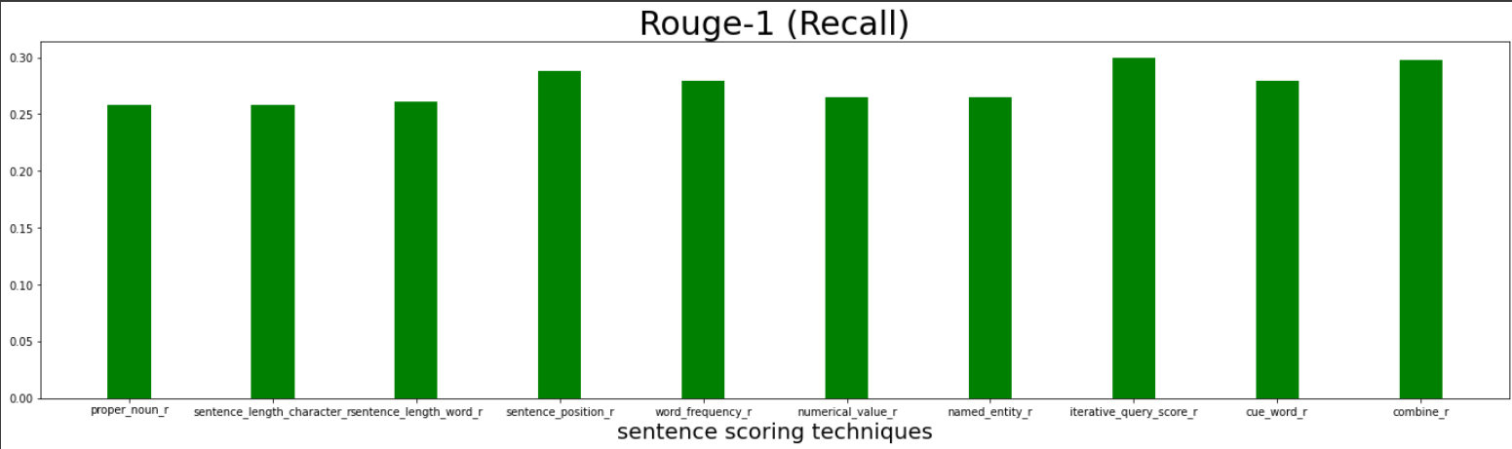

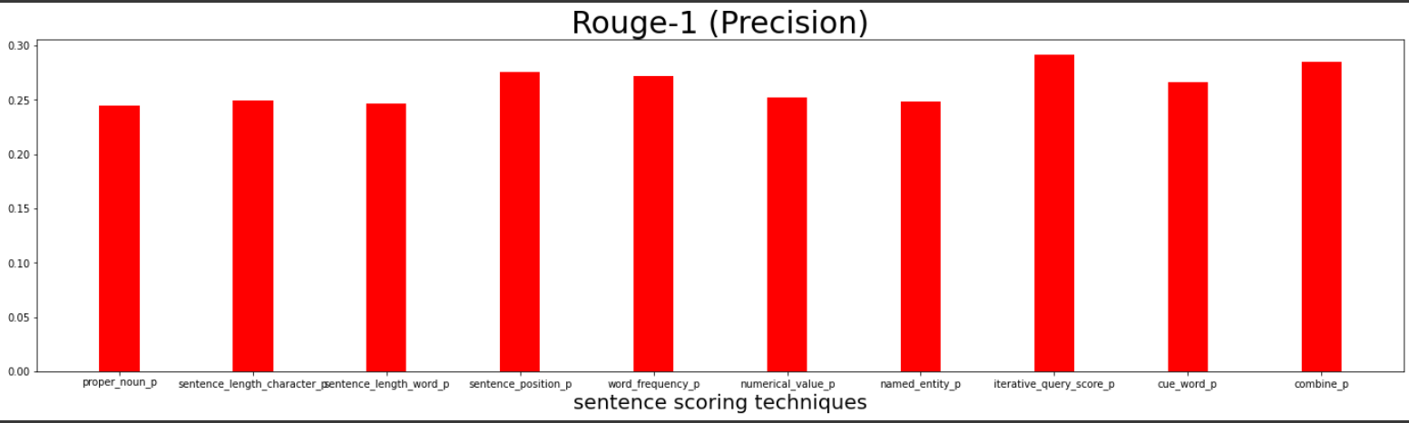

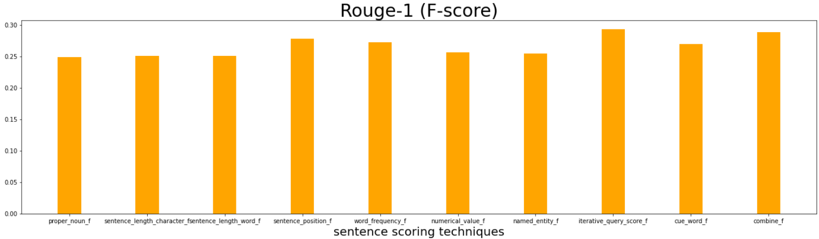

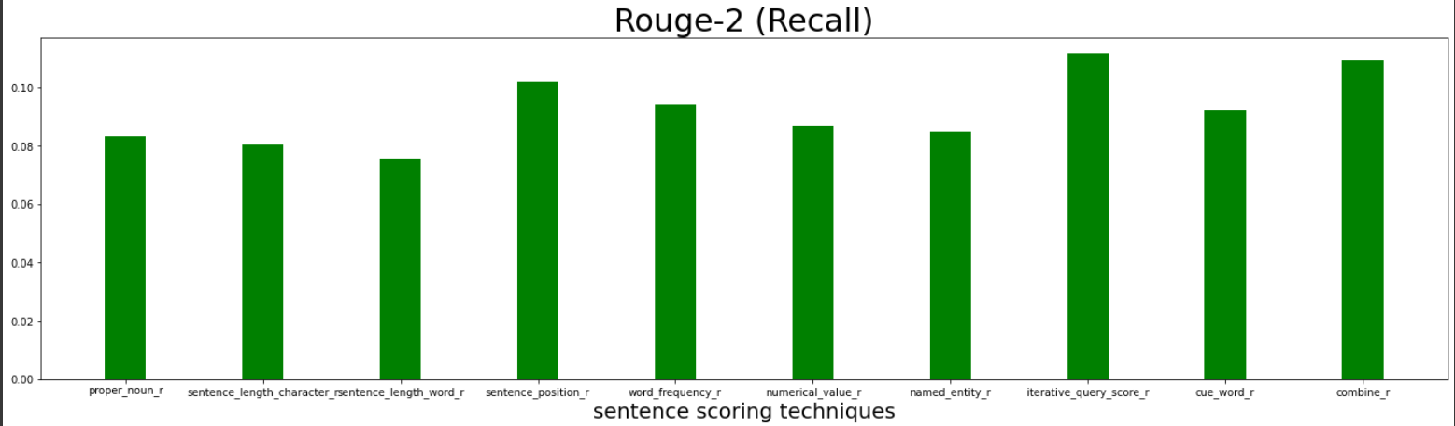

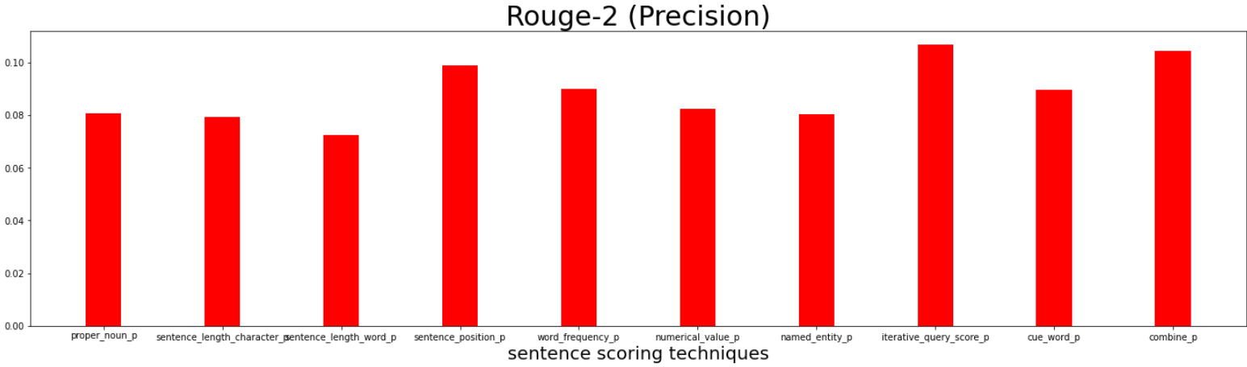

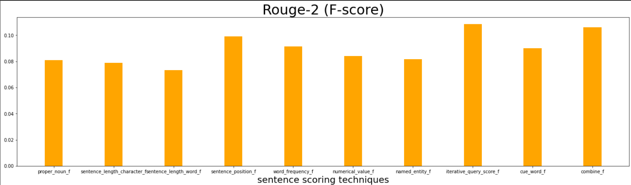

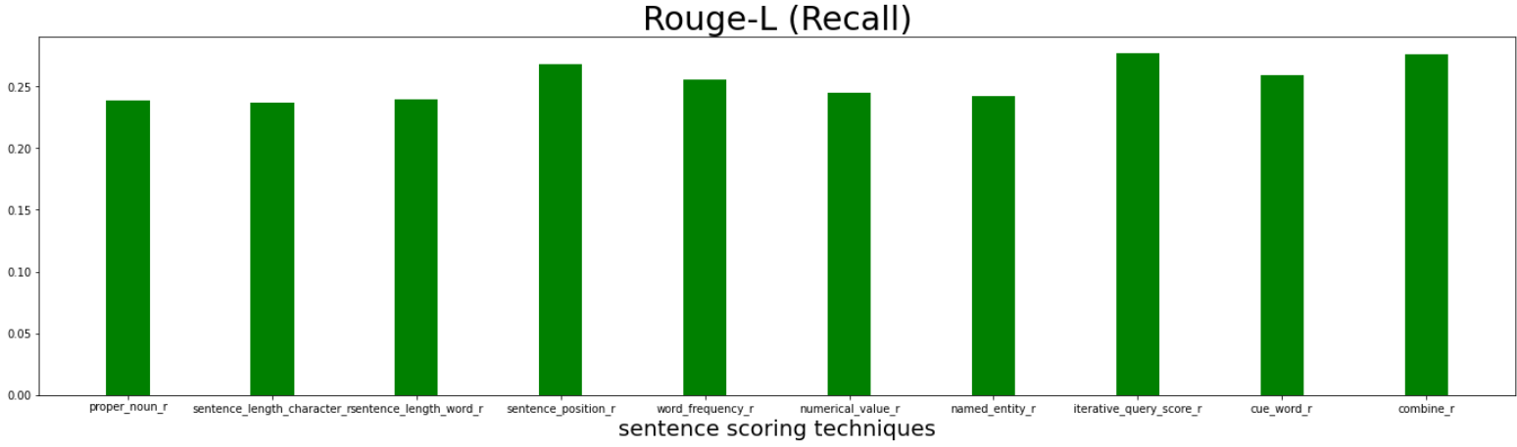

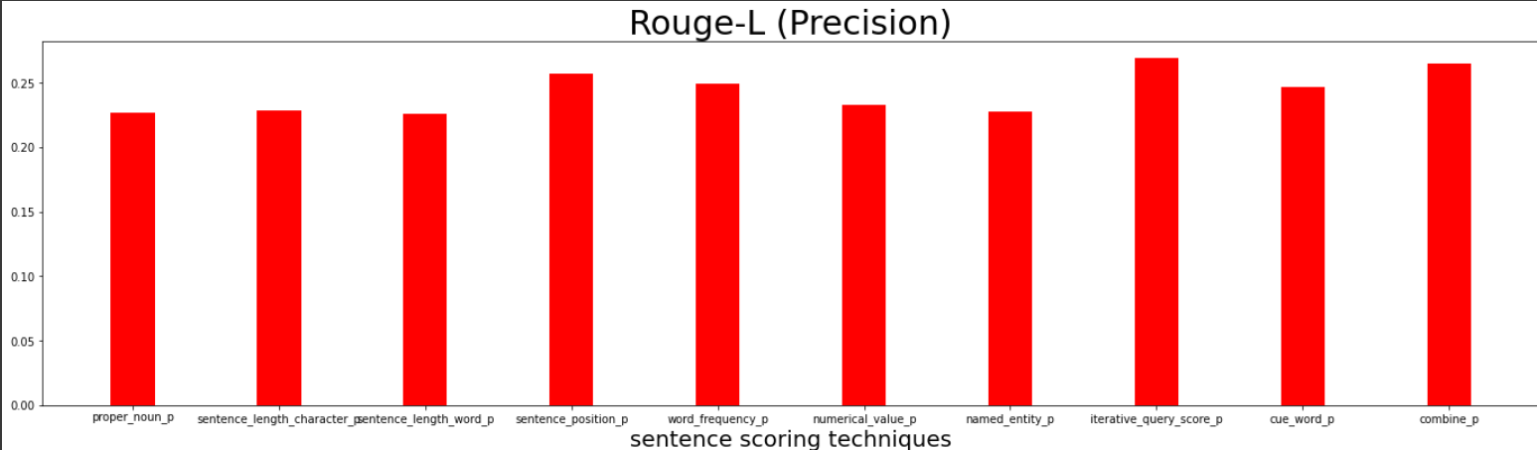

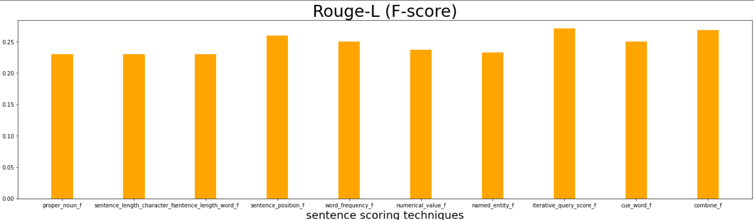

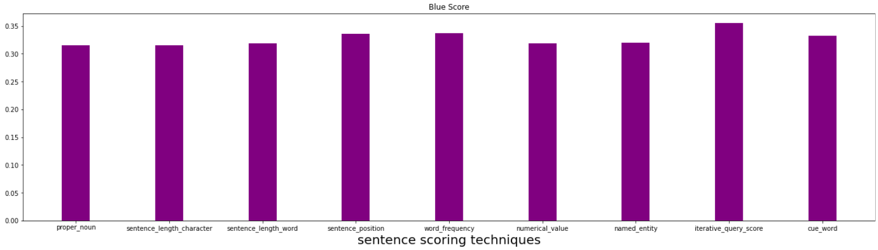

**8. Prototype**

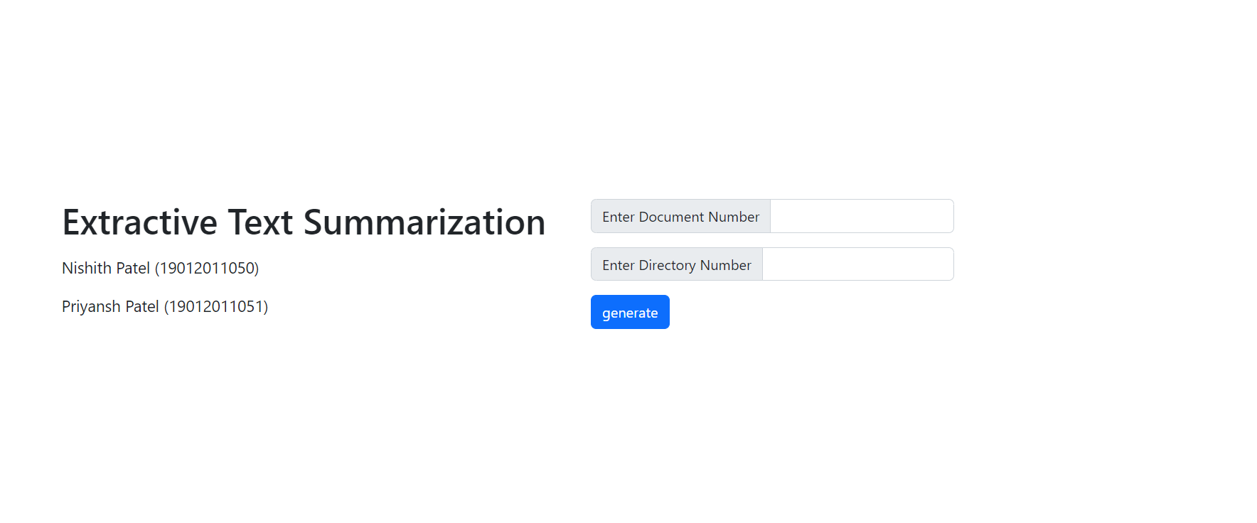

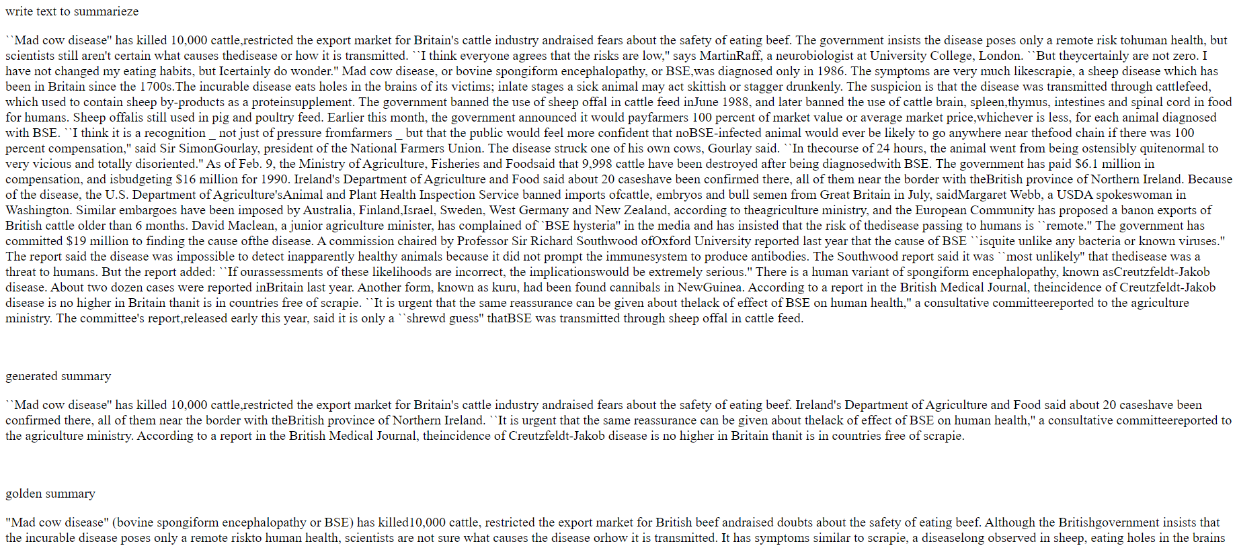

# **9. CONCLUSION**

Hence in this project we have done some of the works in the area of text summarization. Summarization has always been a necessity for many years as there is a huge amount of information being released on the internet every day. This project described all the major summarizations techniques and the prominent works that are being done on each technique. There has always been an improvement to the earlier technique which improved the accuracy like a single document summarization.

This project will be widely used in the future by the all types of users. This project presents algorithm based single document summarizer with the help of sentence scoring method. This project discusses the simple and easy extractive technique of text summarization. This project is done mostly with python and any number of extensions for scoring techniques can easily be added.

**10. REFERENCE**

* <https://www.python.org>
* <https://www.researchgate.com>
* <https://www.towardsdatascience.com>
* <https://sci-hub.com>